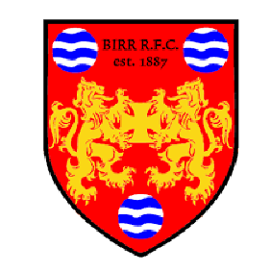
Birr RFC
Vintage Week Mixed Tag Rugby Tournament
August 3rd, 2019 @ 2pm in Birr RFC Pitches

Registration Form
Registration Fee €100

Team Name: ___________________________

Players: (7 male, 3 female)
- ___________________________
- ___________________________
- ___________________________
- ___________________________
- ___________________________
- ___________________________
- ___________________________
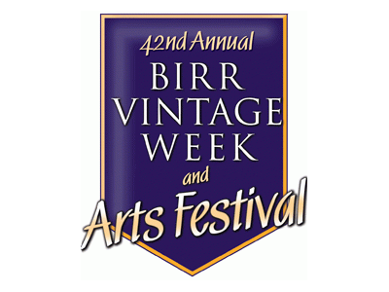
- ___________________________
- ___________________________
- ___________________________
(Office Use Only)
Registration Paid – Amt €________
Initial: _______

